**V506 Practice Midterm Exam**

1. Which of the following is an example of a continuous variable?

***A continuous variable assumes any value within a range. Number of students, zip codes, and rankings have "gaps" between the values and hence are not continuous.***

2. Refer to the following distribution of ages:  
  
 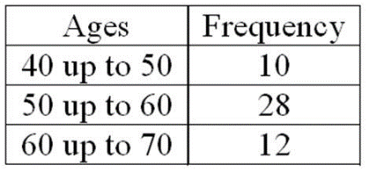   
  
For the distribution of ages just shown, what is the relative class frequency for the lowest class? 

***The answer .20, or 10/50, is found by dividing 10 by the total of 50.***

3. A population consists of all the weights of all defensive tackles on a university's football team. They are Johnson, 204 pounds; Patrick, 215 pounds; Junior, 207 pounds; Kendron, 212 pounds; Nicko, 214 pounds; and Cochran, 208 pounds. What is the population standard deviation (in pounds)? 

*Using formula 3-7, σ = sqrt(94/5) = 4.33, which rounds to 4 pounds*

4. The distribution of a sample of the outside diameters of PVC pipes approximates a symmetrical, bell-shaped distribution. The arithmetic mean is 14.0 inches, and the standard deviation is 0.1 inches. About 68% of the outside diameters lie between what two amounts? 

***Based on the Empirical rule, 68% of observations are within ±1 standard deviation of the mean. The mean is 14.0 and the standard deviation is 0.1, so the limits are 14.0 ± 0.1. The lower limit is 13.9 inches, and the upper limit is 14.1 inches.***

5. A board of directors consists of eight men and four women. A four-member search committee is randomly chosen to recommend a new company president. What is the probability that all four members of the search committee will be women? 

***There are four women in a group of 12 individuals. Therefore, the probability of picking a woman on the first selection is 4/12, the second selection is 3/11, the third selection is 2/10, and the fourth is 1/9. This is an application of the multiplication rule for events that are not independent. The joint probability is (4/12)(3/11)(2/10)(1/9) = 0.002.***

6. A gumball machine has just been filled with 50 black, 150 white, 100 red, and 100 yellow gumballs that have been thoroughly mixed. Sue and Jim each purchase one gumball. What is the likelihood that both Sue and Jim will get red gumballs? 

***The probability of a red gumball on the first selection is 100/400 = .25. The probability of selecting a second red gumball is a conditional probability that assumes the first selection was a red gumball, so the probability of a second red gumball is 99/399. The Joint probability is (100/400)(99/399) = 0.062.***

7. Judging from recent experience, 5% of the computer keyboards produced by an automatic, high-speed machine are defective. If six keyboards are randomly selected, what is the probability that none of the keyboards are defective?   
   
***Applying the binomial distribution, go to the binomial probability table, find the case where the number of trials is n = 6, and the probability of success is π = .05. Find the row where x, the number of successes, is 0. The answer is .735.***

8. Ball-Bearings, Inc. produces ball bearings automatically on a Kronar BBX machine. For one of the ball bearings, the mean diameter is set at 20.00 mm (millimeters). The standard deviation of the production over a long period of time was computed to be 0.150 mm. What percent of the ball bearings will have diameters of 20.27 mm or more? 

***Begin by finding the z value corresponding to 20.27 mm. From z = (x - μ)/σ: z = (x - μ)/σ = (20.27 - 20.00)/0.15 = 1.8. Then, using the "areas under the normal curve" table, find the probability z is more than 1.8 is 0.0359 from 0.5000 - 0.4641. Expressing 0.0359 as a percentage is 3.59%.***

9. A large manufacturing firm tests job applicants. Test scores are normally distributed with a mean of 500 and a standard deviation of 50. Management is considering placing a new hire in an upper-level management position if the person scores in the upper sixth percent of the distribution. What is the lowest score a new hire must earn to qualify for a responsible position?

***Recall that the area under the normal curve to the right of the mean is 0.5000. The area between the mean and the desired "cutoff" score is 0.4400, found by 0.5000 - 0.0600. Now refer to the "areas under the normal curve" table. Search the body of the table for the area closest to 0.4400. The closest area is 0.4406. Move to the margins from this value and read the z value of 1.56. Finally, the lowest score a new hire must earn to qualify is 578, found by: score x + zσ = 500 + 1.56(50).***

10. The true sampling error is usually not known because ________.

|  |  |
| --- | --- |
| **A.** | µ is unknown |

|  |  |
| --- | --- |
| B. | µ is a random variable |

|  |  |
| --- | --- |
| C. | σ2 is unknown |

|  |  |
| --- | --- |
| D. | the sample mean cannot be computed |

***Sampling error, , is the difference between a sample mean and the population mean. Usually we do not know the population mean, so we cannot determine the sampling error.***

11. The size of the sampling error is ________.

|  |  |
| --- | --- |
| A. | directly related to the sample size—in other words, the larger the sample size, the larger the sampling error |

|  |  |
| --- | --- |
| B. | directly related to the population mean—in other words, the larger the mean, the larger the sampling error |

|  |  |
| --- | --- |
| **C.** | inversely related to the sample size—in other words, the larger the sample size, the smaller the sampling error |

|  |  |
| --- | --- |
| D. | inversely related to the population standard deviation—in other words, the smaller the standard deviation, the larger the sampling error |

***The sampling error will be smaller with a larger sample size.***

12. The weight of trucks traveling on a particular section of I-475 has a population mean of 15.8 tons and a population standard deviation of 4.2 tons. What is the probability a state highway inspector could select a sample of 49 trucks and find the sample mean to be 14.3 tons or less? 

***We use the formula 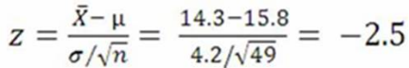. Then, using the "areas under the normal curve" table, P(z ≤ -2.5) = .5000 - .4938 = .0062.***

|  |
| --- |
| 13. A research firm needs to estimate within 3% the proportion of junior executives leaving large manufacturing companies within three years. A 0.95 degree of confidence is to be used. Several years ago, a study revealed that 21% of junior executives left their company within three years. To update this study, how many junior executives should be surveyed?   ***The sample size is n = p(1 - p)[(z/E)]2 = .21(1 - .21)[1.96/.03]2 = 708.13, so we round up to 709.*** |

14. A random sample of 85 supervisors revealed that they worked an average of 6.5 years before being promoted. The population standard deviation was 1.7 years. Using the 0.95 degree of confidence, what is the confidence interval for the population mean? 

***We know the population standard deviation, so we have a z statistic. So, .***

15. Consider a two-tailed test with a level of confidence of 80.30%. The z-value is ________.

***Using the areas under the normal curve: For an area of (0.8030/2) = 0.4015, the corresponding z-value is 1.29.***

16. The mean weight of newborn infants at a community hospital is 6.6 pounds. A sample of seven infants is randomly selected and their weights at birth are recorded as 9.0, 7.3, 6.0, 8.8, 6.8, 8.4, and 6.6 pounds. Does the sample data show a significant increase in the average birthrate at a 5% level of significance?   
   
***H0: µ = 6.6; H1: µ ≠ 6.6. Note that the problem states a one (right)-tailed alternate hypothesis, H1: μ > 6.6. The t critical value for a one-tailed test at the 0.05 significance level with 6 degrees of freedom is +1.943. The t test statistic is 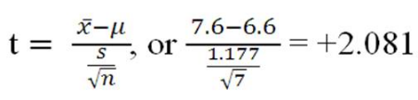. The computed t statistic is in the rejection region, so we reject the null hypothesis and conclude that there has been an increase in the mean weight.***

17. It is claimed that in a bushel of peaches, less than 10% are defective. A sample of 400 peaches is examined and 50 are found to be defective. What is the *p-*value? 

***H0: π ≥ 0.10; H1: π < 0.10. Based on the sample information, the sample proportion p = 50/400 = 0.125, and 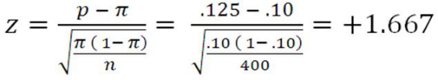. The p-value is the probability of observing a sample value more extreme than the value observed, given that the null hypothesis is true. Because the hypothesis is one (left)-tailed, we need the probability of obtaining a value less than +1.667 when the null hypothesis is true. Referring to the "areas under the normal curve" table, the probability for z = 1.67 is 0.4525. The total area to the left of 1.67 is .9525 (.5000 + .4525).***

18. A null hypothesis makes a claim about a __________.

|  |  |
| --- | --- |
| **A.** | Population parameter |

|  |  |
| --- | --- |
| B. | Sample statistic |

|  |  |
| --- | --- |
| C. | Sample mean |

|  |  |
| --- | --- |
| D. | Type II error |

***A null hypothesis is a statement about the value of a population parameter.***

19. A recent study focused on the amount of money single men and women save monthly. The information is summarized next. Assume that the population standard deviations are equal.  
  
 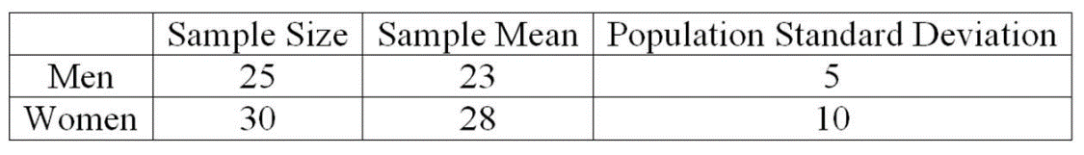   
  
At the .01 significance level, what is the conclusion about the way women and men save? 

***The decision rule is to reject the null hypothesis if the computed value is greater than 2.369. To determine the value of the test statistic, the first step is to pool the sample standard deviations. . The value of the test statistic is 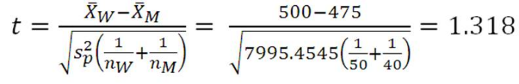. The computed value of the test statistic is less than the critical value, so we fail to reject the null hypothesis.***

20. An investigation of the effectiveness of a training program to improve customer relationships included a pre-training and post-training customer survey. To compare the differences they computed (post-training survey score - pre-training survey score). Seven customers were randomly selected and completed both surveys. The results follow.

|  |
| --- |
| What is the value of the test statistic?  ***This is a one-tailed test because the purpose of the training is to improve customer relationships. So calculating the difference (post-training survey - pre-training survey), we expect this difference to be greater than zero. The null hypothesis is H0: µd ≤ 0; the alternate hypothesis would be: H1: µd > 0. The t-statistic is applied. To find the value of the test statistic, calculate the mean and standard deviation of the differences for the seven customers. The mean is 2, and the standard deviation is 2.082. So the t test statistic is*** |